CREATE database Bank_Database_CS154;

SHOW DATABASES;

use Bank_Database_CS154;

create table Branch(branch_name varchar(20),

city varchar(20),

assets varchar(20),

primary key(branch_name));

create table BankAccount(accno varchar(20),

branch_name varchar(20),

balance varchar(20),

primary key(accno,branch_name),

foreign key(branch_name) references Branch(branch_name));

create table BankCustomer(name varchar(20),street varchar(20),city varchar(20),

primary key(name));

create table Depositer(name varchar(20),

accno varchar(20),

primary key(name,accno),

foreign key(accno) references BankAccount(accno));

create table Loan(loan_number varchar(20),

branch_name varchar(20),

amount varchar(20),

primary key(loan_number,branch_name),

foreign key(branch_name) references Branch(branch_name));

insert into Branch values("SBI_Chamarajpet","Bangalore",50000);

insert into Branch values("SBI_ResidencyRoad",'Banagalore',10000);

insert into Branch values("SBI_ShivajiRoad",'Bombay',20000);

insert into Branch values("SBI_ParliamentRoad",'Delhi',10000);

insert into Branch values("SBI_JantarMantar",'Delhi',20000);

insert into BankAccount values(1,"SBI_Chamarajpet",2000);

insert into BankAccount values(2,"SBI_ResidencyRoad",5000);

insert into BankAccount values(3,"SBI_ShivajiRoad",6000);

insert into BankAccount values(4,"SBI_ParliamentRoad",9000);

insert into BankAccount values(5,"SBI_JantarMantar",8000);

insert into BankAccount values(6,"SBI_ShivajiRoad",4000);

insert into BankAccount values(8,"SBI_ResidencyRoad",8000);

insert into BankAccount values(9,"SBI_ParliamentRoad",8000);

insert into BankAccount values(10,"SBI_ResidencyRoad",8000);

insert into BankAccount values(11,"SBI_JantarMantar",8000);

insert into BankCustomer values("Avinash", "Bull temple road","Bangalore" );

insert into BankCustomer values("Dinesh", "Bannerghatta Road","Bangalore" );

insert into BankCustomer values("Mohan", "NationalCollegeRoad","Bangalore" );

insert into BankCustomer values("Nikhil", "Akbar Road","Delhi" );

insert into BankCustomer values("Ravi", "Prithviraj Road","Delhi" );

insert into Depositer values("Avinash", 1);

insert into Depositer values("Dinesh", 2);

insert into Depositer values("Mohan", 3);

insert into Depositer values("Nikhil", 4);

insert into Depositer values("Ravi", 5);

insert into Depositer values("Avinash", 8);

insert into Depositer values("Nikhil", 9);

insert into Depositer values("Dinesh", 10);

insert into Depositer values("Nikhil", 11);

insert into Loan values(1, "SBI_Chamarajpet", 1000);

insert into Loan values(2, "SBI_ResidencyRoad", 2000);

insert into Loan values(3, "SBI_ShivajiRoad", 3000);

insert into Loan values(4, "SBI_ParliamentRoad", 4000);

insert into Loan values(5, "SBI_Jantarmantar", 5000);

select * from Branch;

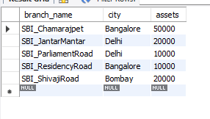

select * from BankAccount;

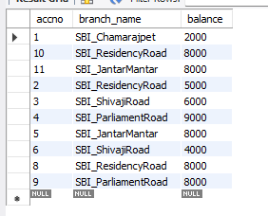

select * from BankCustomer;

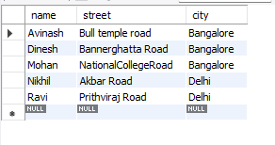

select * from Depositer;

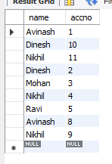

select *from Loan;

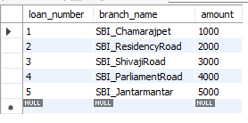

alter table Branch change assets assets_inlakhs real;

select * from Branch;

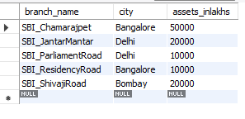

select d.name from Depositer d, BankAccount b

where b.branch_name="SBI_ResidencyRoad" and

d.accno =b.accno group by d.name having count(d.accno)>=2;



create view br as select branch_name, sum(amount)

from loan group by branch_name;

select * from br;

